***Drip Irrigation Using Helianthus Panel***

**Aim:**

To create a drip irrigation system using a solar panel tracker.

**Introduction:**

Introducing a drip irrigation system powered by a helianthus panel: a sustainable solution merging solar energy with efficient irrigation.

The helianthus panel, or solar panel, captures sunlight and converts it into electricity to fuel the drip irrigation system. This eco-friendly approach reduces reliance on traditional power sources, cuts operating costs, and minimizes carbon emissions. It's a brief but powerful combination of innovation and sustainability in irrigation

**Procedure:**

**Part I:**

Connect the solar panel and SG90 servo motor and fix it to a board, such a way that it can move.

Connect all the wires to the solar panel and the Arduino following the circuit.

Place the Arduino Board and add the code to the Arduino board, so that the panel can track the light and move according to it .

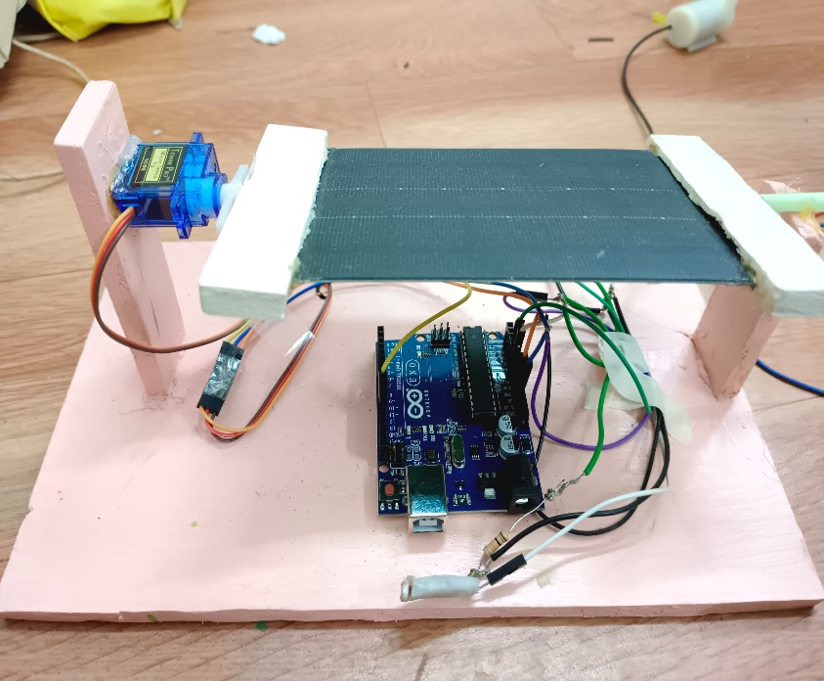

**Part II:**

Take a cardboard make some holes and place plants in it.

Make a cardboard in which we place a motor and a pipe.

Connect the wires of the fountain to the solar panel.

Place a plastic cylinder wrapped around a cardboard which acts as a water tank

Place a plastic pipe which supplies the water to the plants from the water tank

The solar panel provides energy which supplies the water from the tank to the plants.

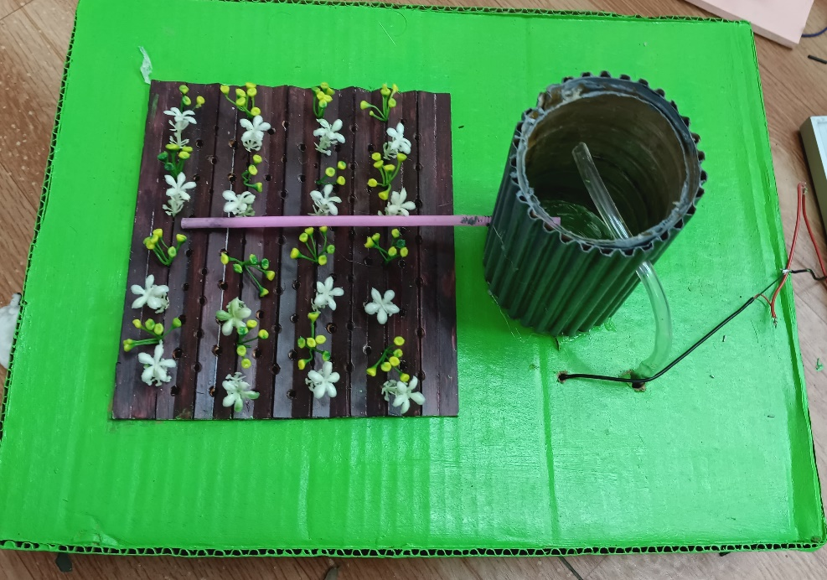

**Uses of the project:**

**Agricultural Irrigation:** Efficiently waters crops using solar power, reducing reliance on non-renewable energy.

**Landscaping:** Keeps gardens and lawns green with eco-friendly irrigation methods.

**Remote Areas:** Provides reliable irrigation in off-grid locations without electricity access.

**Water Conservation:** Precisely distributes water, promoting responsible usage and conserving resources.

**Cost Savings:** Lowers operational costs over time by eliminating fuel or electricity expenses.

**Boosting Power:** Trackers help panels get maximum sunlight for more electricity.

**Stabilizing Grid:** Trackers make solar power more reliable, keeping the electricity grid steady.

**Conclusion:**

A drip irrigation is created using the helianthus panel.

The solar panel generates the energy and this energy is used to water the plants by the process of drip irrigation.